EMEKA
Manga Character Profile Dossier | BAN240
ORIGINAL CHARACTER · TORONTO METROPOLITAN UNIVERSITY · BUSINESS ANALYTICS PROGRAMME
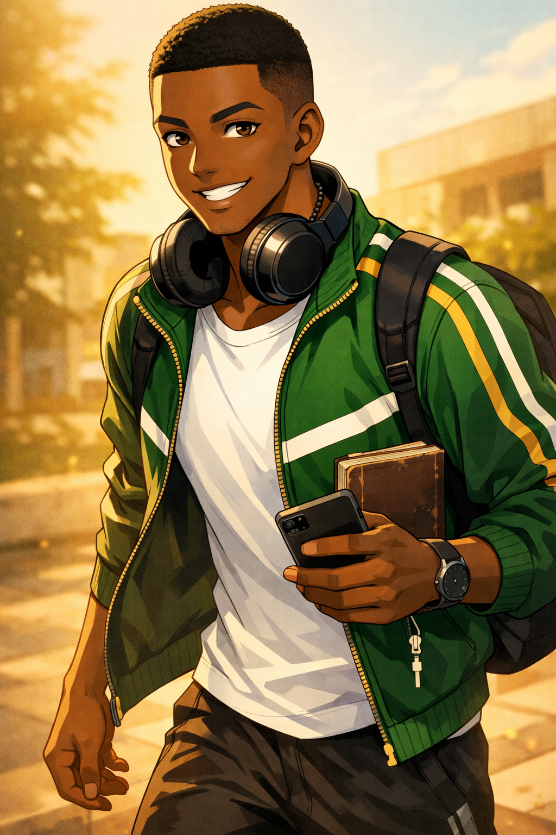

SECTION 01

BIOGRAPHICAL OVERVIEW
Emeka is a fully realized manga character in every sense of the phrase. Charismatic by calibration, entrepreneurially-wired by nature, and fuelled by an ambition that arrived with him in his carry-on before he ever boarded a flight to Toronto, he is the person who makes every room he enters feel slightly more alive — not because he is performing, but because he is genuinely, relentlessly engaged. He is the one who texts the professor when the whole class is confused. He organizes the group dinner and actually confirms the time. He has two business ideas currently "incubating" in a dedicated notes app, a folder titled simply The Plan. His story is not the familiar arc of a young man searching for drive — he arrived with plenty. It is something quieter and more interesting: the story of learning that building something lasting sometimes requires slowing down, trusting other people, and admitting that the 23-year-old carrying the expectations of an entire extended family might occasionally need to rest.
✦
Manga Framing:
Emeka is a catalyst character — not a side character who supports the protagonist, but a force of narrative gravity that other characters orient around. His presence raises the stakes of any scene he enters.
SECTION 02

DEMOGRAPHICS & BASIC INFORMATION
Full Name | Chukwuemeka "Emeka" Obi
Age | 23
Gender | Male
Ethnicity | Nigerian (Igbo)
Hometown | Lagos, Nigeria
Current City | Scarborough, Ontario, Canada
Living Situation | Shares a basement apartment with two other Nigerian international students near the Warden/Lawrence area
Immigration Status | International student visa
Occupation | Full-time undergraduate student
University | Toronto Metropolitan University (TMU)
Programme | Business Analytics
Year of Study | 2nd Year
SECTION 03

PHYSICAL APPEARANCE & MANGA PORTRAIT BRIEF
Height | 6'1"
Build | Athletic, broad-shouldered; natural forward lean when walking — like he is perpetually mid-stride toward something
Hair | Short, close-cropped fade; clean lines; sometimes wears a fitted cap
Eyes | Dark brown, alert and scanning; "strategic assessment" is his resting expression — warm the moment he smiles
Skin Tone | Deep rich brown
Typical Outfit | Crisp track jacket or puffer vest over a clean fitted tee; joggers or dark slim jeans; fresh white or black sneakers — always looks put-together without visible effort
Accessories | Over-ear headphones (Afrobeats, always); slim backpack; worn pocket notebook treated like a business ledger; phone in hand with at least three apps open

Manga Art Style Notes
• Wide sparkle-eyes: Triggers during Arsenal match moments or when a business idea strikes with full force
• Dramatic lightning-bolt background: Reserved for competitive FIFA sessions that have gone beyond casual
• Chibi mode: Activates when offered food that is objectively inferior to his own cooking
• Golden sunrise aesthetic: Appears behind him whenever he delivers an unexpectedly wise observation to someone who was not prepared for it
• Scanning expression: Drawn with subtle sharp lines to convey quiet intelligence operating beneath the warmth — the expression of someone who has already read the room before anyone else noticed him doing it

SECTION 04

PERSONALITY & DEFINING QUIRKS
- Confident and charismatic by default — not performative, just calibrated. He assumes things will work out because they usually do when he applies effort. This is not arrogance; it is a track record.
- Entrepreneurial instinct running constantly in the background — he is always half-noticing a gap in a market, a problem that needs a product, or a service TMU students would pay for. The front of his mind is in the lecture; the back is already drafting a pitch deck.
- "Canada Things That Make No Sense" — a running note on his phone. Current entries include: poutine at breakfast, Tim Hortons loyalty, the concept of a "light" winter, and the idea that a 5-minute walk in −15°C is considered reasonable by any standard of human dignity.
- Strategic acceptance of Tim Hortons — it is not good coffee, but it is everywhere, and he respects the logistics. He orders a medium double-double with the composure of a man who has made peace with his circumstances.
- Claims to be a casual Arsenal fan — his match-day routine (pre-match playlist, no incoming calls, specific seating position on the couch, exact snack configuration) suggests otherwise.
- Nigerian jollof rice vs. Ghanaian jollof rice — this is not a debate he will entertain. The answer is established. He moves on.
- Group chat admin — for every WhatsApp group he is part of, without exception. Sends voice notes that run four minutes minimum. Does not apologize for their length.
- Sunday calls home — his parents, grandmother, and at least one uncle all expect updates. The call rarely ends in under an hour. This is the most important standing appointment on his calendar.
- Will negotiate a discount on almost anything — Facebook Marketplace, campus bookstores, service vendors. He considers this a life skill, not a personality flaw, and he is correct.
"There is always space. I have measured it. It fits." — Emeka, regarding the TTC subway doors closing on people who chose not to board

SECTION 05

HOBBIES & INTERESTS
01 · Football (Soccer)
Primary passion. Plays striker in a Scarborough recreational league on weekends, with a level of competitive intensity that other players describe as "good-natured but a lot." Follows Arsenal FC in the Premier League with deep, occasionally painful commitment. Follows the Super Eagles internationally with full emotional investment. FIFA (the video game) is played with a seriousness that significantly exceeds the "casual" label he applies to it.
02 · Afrobeats
Deeply embedded musical identity. Burna Boy, Wizkid, Asake, and Davido are non-negotiable fixtures. Makes situation-specific playlists — commute, studying, cooking, pre-match hype — with curatorial precision. Considers Afrobeats' global mainstream rise a personal vindication of something he always knew.
03 · Entrepreneurship & Side Hustles
Facebook Marketplace flipping across electronics, textbooks, and furniture. Freelance graphic design work (past tense, but the skills remain active). Currently developing two business concepts he declines to describe in detail until they are "further along." Has a separate notebook section titled Competitive Moats.
04 · Cooking Nigerian Food
Jollof rice (non-negotiable), egusi soup, pepper soup, suya-style grilled chicken. Has reverse-engineered his mother's recipes with approximately 80% accuracy. The remaining 20% haunts him. The smell of his Tupperware lunch in the TMU microwave draws commentary from strangers, which he receives as compliments — because they are.
05 · Gaming (FIFA)
Tracks his Ultimate Team win/loss record in a spreadsheet. Treats squad building like portfolio management, applying actual transfer market logic. Occasional Warzone sessions with roommates — these are casual by comparison and he allows himself to be bad at them.
06 · Nigerian Comedy & Digital Content
Deeply familiar with Nigerian skit culture — Mark Angel, Brodashaggi, Sydney Talker. Can quote extended segments from memory. Occasional TikTok lurker who never posts but evaluates content with the quiet confidence of someone who knows precisely what works and what does not. He will tell you, if you ask.
SECTION 06

SPORTS PROFILE
Primary Fan Sport | Football — Arsenal FC (Premier League) Precise match knowledge, strong transfer window opinions, a measured but pained relationship with Arsenal's history of near-misses. Match-day rituals are not negotiable. Responds to the word "Tottenham" the way other people respond to a jump scare.
International Fan Sport | Football — Super Eagles (Nigeria National Team) Emotional investment is significant and sincere. AFCON tournaments are high-stakes household events. Watches with full commitment regardless of time zone implications.
Participatory Sport | Football — Scarborough Recreational League (Striker) Competitive, good-natured, gets called for intensity approximately once per session. Has not changed this and does not plan to.
Secondary Fan Sport | Basketball — FIBA / D'Tigers (Nigeria National Team) Not a deep NBA follower, but watches FIBA competitions when Nigeria qualifies. Respects the sport without being captured by it.
Anime Sports Influence | Blue Lock Blue Lock made him reconsider his feelings about individualism vs. team play in football. He will not admit this. His tactical opinions shifted measurably after finishing it in four days. He has been asked about this; he changes the subject.

SECTION 07

FANDOMS
⚽ Arsenal FC
Deep, occasionally painful fandom. Match-day rituals are sacred and non-negotiable. Responds to "Tottenham" the way others respond to a jump scare. Has opinions about every major Arsenal signing since 2018 and will share them unprompted.

🦅 Super Eagles — Nigeria National Football Team
Emotional investment is significant and sincere. AFCON tournaments are high-stakes events in the apartment. Watches every qualifying match regardless of what else is scheduled.

🎵 Burna Boy
Primary music artist fandom. "African Giant" is not just an album title — it is a framing he applies to his own ambitions. Has seen him live once in Lagos. Considers this a formative experience he does not over-explain.

🎵 Wizkid / Afrobeats Broadly
Follows the entire Afrobeats scene with encyclopaedic awareness. Knows every feature, every era, every significant beef, every moment the genre broke internationally. This is not casual knowledge — it is maintained.

🎵 Asake
Recent and enthusiastic addition to the regular rotation. Plays Mr. Money With The Vibe on repeat during study sessions. Describes his sound as "maximum output energy" — a description he considers self-evidently accurate.

😂 Nigerian Comedy / Skit Culture
Mark Angel, Brodashaggi, Sydney Talker. Can quote entire skits from memory with accurate delivery. This is how he decompresses. If he is quoting, it is going well.

🎮 FIFA — Ultimate Team
Treats his Ultimate Team as a fandom unto itself. Follows FIFA content creators. Has opinions about game mechanics — specific, technical, deeply-held opinions — that take more than a few sentences to properly articulate and he will give you the full version.

📖 Blue Lock (Manga/Anime)
Reluctant convert. Initially dismissed it. Finished it in four days. Declines to discuss how much it affected his football philosophy, which is itself informative. Has since recommended it to three people while claiming he is "not that into it."

SECTION 08

COMMUTE & DAILY LIFE
Home Base | Scarborough, Ontario — Warden/Lawrence area (east end of Toronto)
Commute Route | TTC surface bus → Warden Station (Line 2 subway, eastbound to westbound) → transfer at Bloor-Yonge or Dundas → TTC south to TMU campus
Commute Duration | ~50–60 minutes each way
Commute Mood | Afrobeats in over-ear headphones; eyes closed or half-closed; head nodding slightly. Technically present on the subway. Mentally in Lagos, or deep inside a business concept, or both simultaneously.
Signature Commute Move | Makes sustained eye contact with anyone who looks at him and somehow this turns into a full conversation. Has made three genuine, lasting friends on the TTC in six months. This is not an accident.
Transit Pet Peeve | "There is always space. I have measured it. It fits." — regarding passengers who allow subway doors to close without attempting to board.

On-Campus Routine
- Arrives and immediately identifies the most powerful outlet in the room; workstation setup follows: laptop, pocket notebook, phone on the table, headphones off but around neck (listening mode suspended, not terminated)
- Tim Hortons in hand as a tribute to Canadian logistics — not enthusiasm, tribute
- Home-cooked jollof rice in a Tupperware container three days a week; warmed in the microwave without apology; the smell draws commentary which he receives as compliments
- The remaining two days: the Halal spot near campus, ordered with familiarity of a regular

After-Class Pattern
- Either the library — where his business notebook and lecture notes share a table and it is not always clear which one is receiving more active attention
- Or a long walk from the bus stop to the apartment, talking to his parents — the Sunday call has weekday overflow, and he allows it

The Sunday Call: Non-negotiable standing appointment. Parents, grandmother, and at least one uncle all expect updates. Duration: rarely under one hour. Function: the performance drops, the business-analyst mode goes offline, and he is simply a 23-year-old talking to his mother. These are his most honest moments.
SECTION 09

CHARACTER ROLE & NARRATIVE FUNCTION
Emeka is the catalyst character — the one who makes things happen, not because he is assigned to, but because inaction is physically uncomfortable for him. In a school manga, he is the student who forms the club, recruits the members, and has three contingency plans before anyone else has finished reading the premise. His narrative gravity is not aggressive; it is simply persistent. Other characters orient around him before they fully realize they are doing so.
His arc is deceptively complex beneath the confidence. The ambition that drives him is also the weight he carries: the expectation of an entire extended family, the cost of a visa and a plane ticket and two years of rent, all compressed into every assignment grade and every networking event he attends. He arrived having already decided he would succeed. The question his arc poses is not whether — it is how, and at what cost, and what kind of person remains when the sprint becomes a marathon.
His growth comes not from gaining ambition but from learning that sustainable success requires rest, trust in people who are not him, and the occasional admission that he does not have all the answers yet. His most powerful scenes are not the victories. They are the quiet Sunday calls home, when the performance drops and he is just a 23-year-old talking to his mother, and the distance between Lagos and Scarborough collapses into something that fits inside a phone screen.
He is, in the truest manga sense, someone you root for — not because his success is guaranteed, but because you can see exactly what it would cost him to fail, and exactly what it would mean to everyone who is watching from home.

SUPPLEMENTAL

CHARACTER STAT SUMMARY
Stat | Rating | Notes
Charisma | ★★★★★ | Default setting; not deployed, simply present
Entrepreneurial Drive | ★★★★★ | Running in background at all times; cannot be fully disabled
Football (Playing) | ★★★★☆ | Striker; technically strong; intensity occasionally flagged
Football (FIFA) | ★★★★★ | Self-rated as ★★★☆☆; this is incorrect
Cooking | ★★★★☆ | 80% of mother's level; the gap is felt deeply
Negotiation | ★★★★★ | Considered a life skill; applied universally
Strategic Patience | ★★★☆☆ | Active development area; improving; arc in progress
Cold Weather Tolerance | ★★☆☆☆ | Has reached détente with Canadian winter; détente is not acceptance
Vulnerability (when needed) | ★★★☆☆ | Present; mostly surfaced only on Sunday calls home

BAN240 · Manga Character Sheet · Chukwuemeka "Emeka" Obi · Toronto Metropolitan University · Original Character

